Sri Lanka Institute of Information Technology



Assignment 1
<<Group Number>>
<<Project Title>>

Internet and Web Technologies – IT1100
B.Sc. (Hons) in Information Technology

Group Details
Group Number:
Project Title:
 | Student ID | Student Name | Email | Contact Number
1 | <<Leader’s Details>>
2
3
4
5

Introduction
<<Give a brief introduction about your project [About half a page]>>

Personas

<<Use the same format for all 5 personas>>
- Example :Customer – Purchasing a book
Online Book Shop – User account Details
<<image>> | Name: Kamal Fernando
<<image>> | Age: 18
<<image>> | Motivation: To learn HTML
<<image>> | Goals: Purchase books regarding HTML
<<image>> | Technical Ability: Professional at work with technology

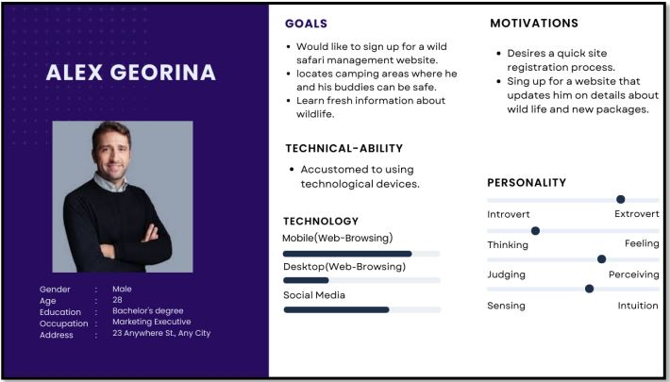

User Journeys
<<Use following format for all 5 user journeys>>
- Example: Persona-Customer User Journey-Purchasing a book
Login to the site
Search books
Land on the site via online advertisement

Confirm purchasing
Add payment details

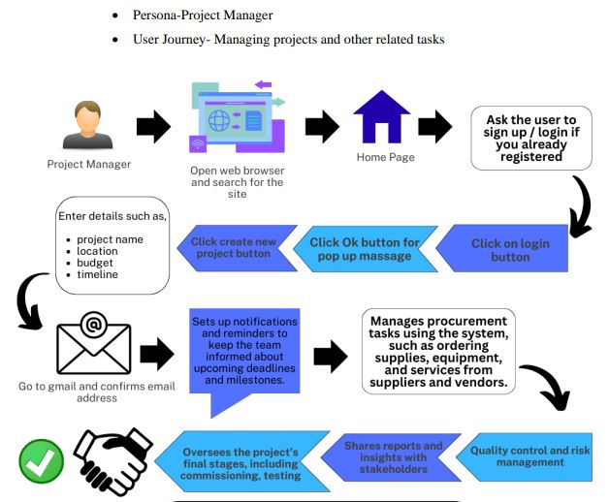

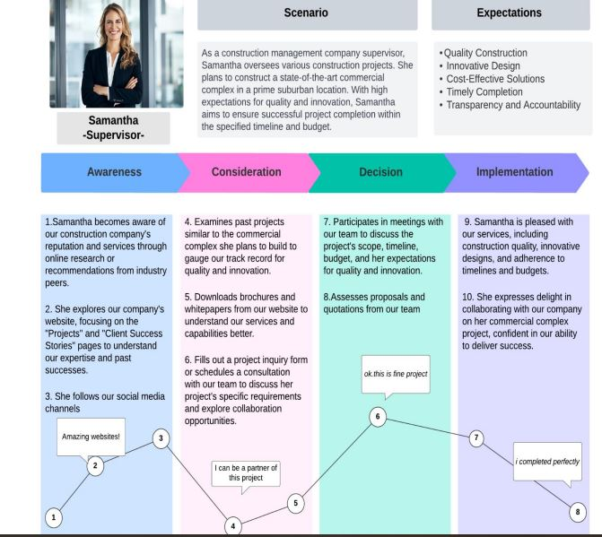

Wire Frames
- Home Page
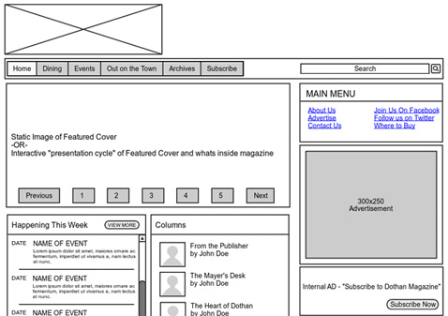

<<Note: Include wireframes for all the pages in your proposed web application. If you have identified more pages other than above pages, please include them as well. >>

Individual Contribution
 | Student ID | Student Name | Individual Contribution
1 | ITXXXXXX |  | - Persona: Customer Purchasing a book  - User Journey: Purchasing a book  - Wireframe: Home page
2
3
4
5

<<IMPORTANT: Please upload the pdf format of your document only by one person from the group >>

